b

**Cameron Webb**

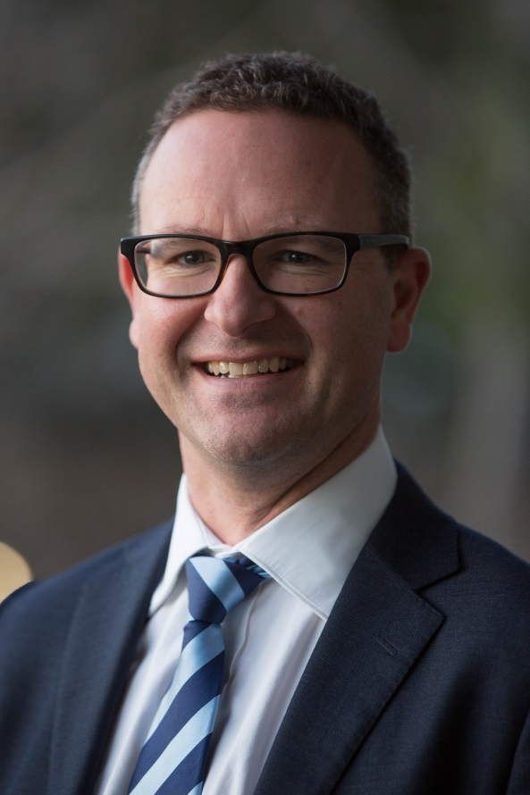

**QUALIFICATIONS**

B.Bus. - Bachelor Business (Retail Management) – Victoria University of Technology

MBA – Masters Business Administration – Macquarie Graduate School of Management

**MOTIVATION FOR BEING A DIRECTOR OF BAPTISTCARE**

The thing I love about BaptistCare is the quality of the services that seek to serve those that need support in our community. It is a fantastic expression of servant hood. I hope that my skills assist the organisation to do an outstanding job of serving those in the community that need help, support and care.

**BOARD ROLE**

Director

Chair of the Property Committee

Member of the Care & Clinical Governance Committee

Member of the Acquisitions Committee

Member of the Audit & Risk Committee

**PROFESSIONAL EXPERIENCE**

Cameron is a senior Transformation & Technology leader in a large Australian public company. His primary responsibility at work is to design, build deploy changes to business that brings the business strategy to life. He also has accountability for the technology teams of that organisation

He has over a decade of large scale technology and transformation delivery.

Cameron has spent a number of years as a business consultant focused on technology.

**COMMUNITY INVOLVEMENT**

Cameron is a member of Dural Baptist Church. He has previously been a Church Council member and has been the Chair of the Council for a period of about 8 years. The Council of Church members is the primary governance body at Dural. Cameron is a drummer and involved in the creative ministries team and he and his wife perform pre-marriage courses for people about to be married.

**FAMILY**

Cameron has been married to Sue for 30 years and has two daughters, Courtney 27 married to Jacob and Brittany 24 married to Tom. He is a Grandfather to Charli.