**MOTIVATION FOR BEING A DIRECTOR**

**BOARD ROLE**

Director

Member of the Care & Clinical Governance Committee

**PROFESSIONAL EXPERIENCE**

Dr O’Donnell is a practicising Occupational Therapist with extensive clinical, research, educational and business expertise with experience also in health management and quality improvement. She is the co-owner and Director of a clinical, research and educational business called The Institute of Driver Health, which provides services to people receiving aged-care services, NDIS clients and people with medical conditions. Joan is also an Honorary Lecturer at the University of Sydney where she continues to supervise higher degree research students. While only becoming a director of BaptistCare in April 2023, Joan has been a member of the Care & Clinical Governance Committee since 2017.

**COMMUNITY INVOLVEMENT**

Dr O’Donnell is a member of Ashfield Baptist Church.

**FAMILY**

.

**Dr Joan O’Donnell**

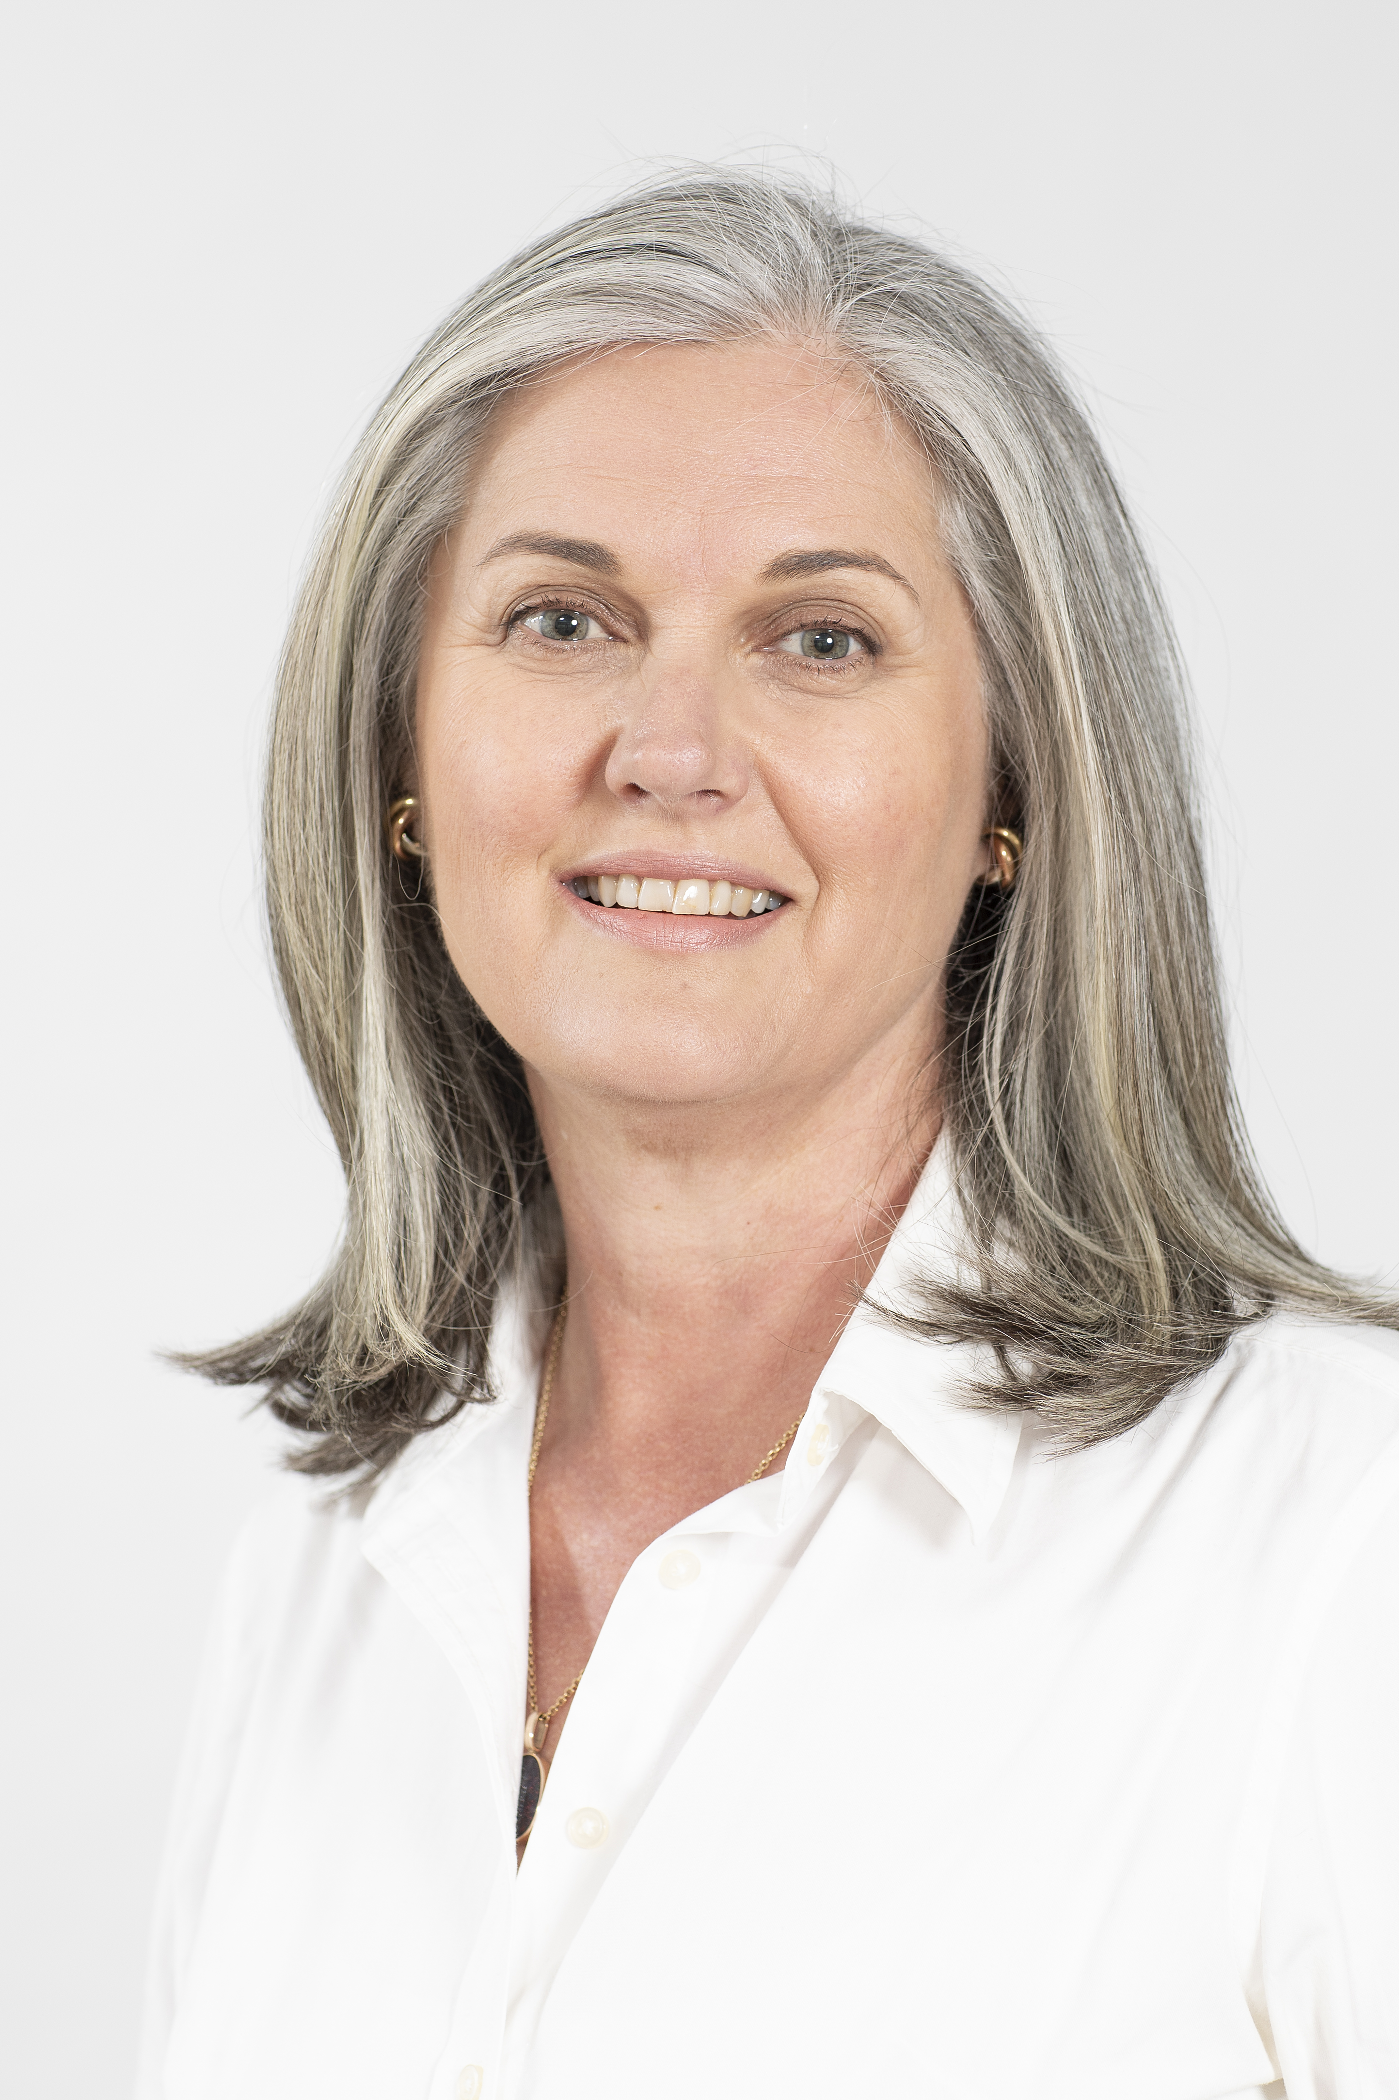

**QUALIFICATIONS**

PhD MSc(Med) BAppSc(OT)